*Level 0*

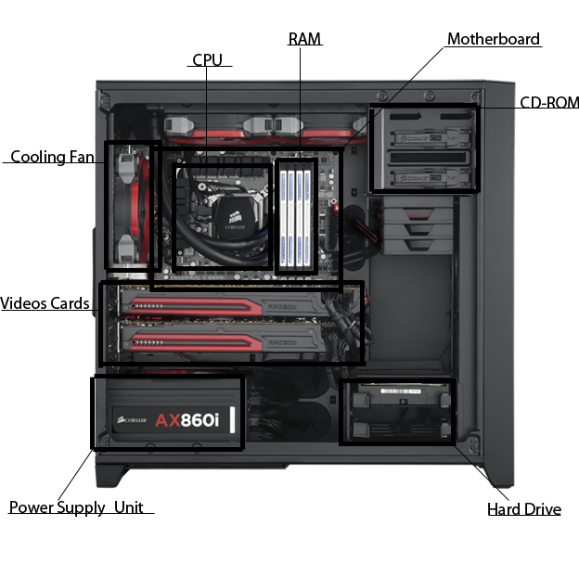

CD-ROM- Media Driver(s)

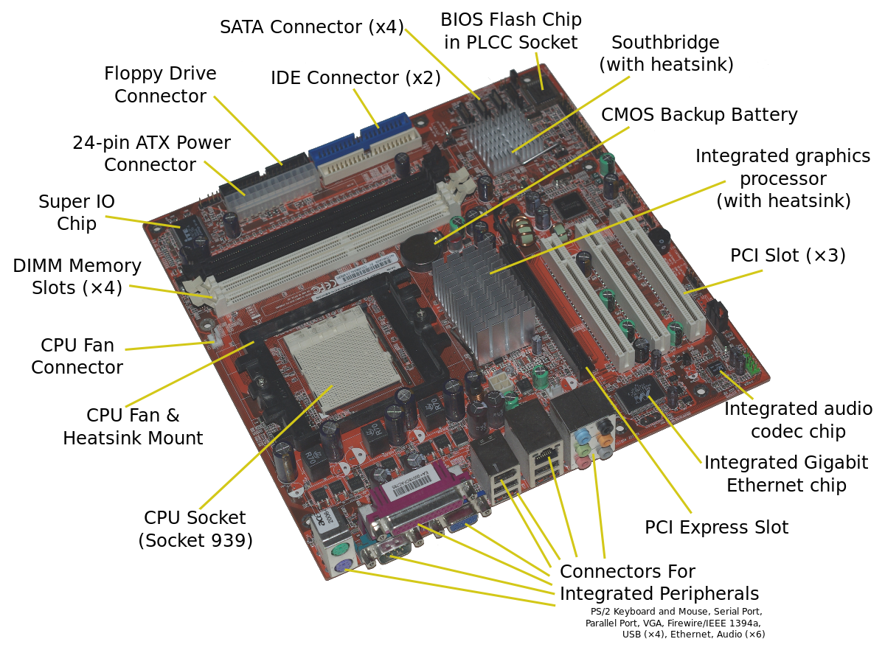

* <https://en.wikipedia.org/wiki/Motherboard>

1. (Also Refer To First Picture In Document)

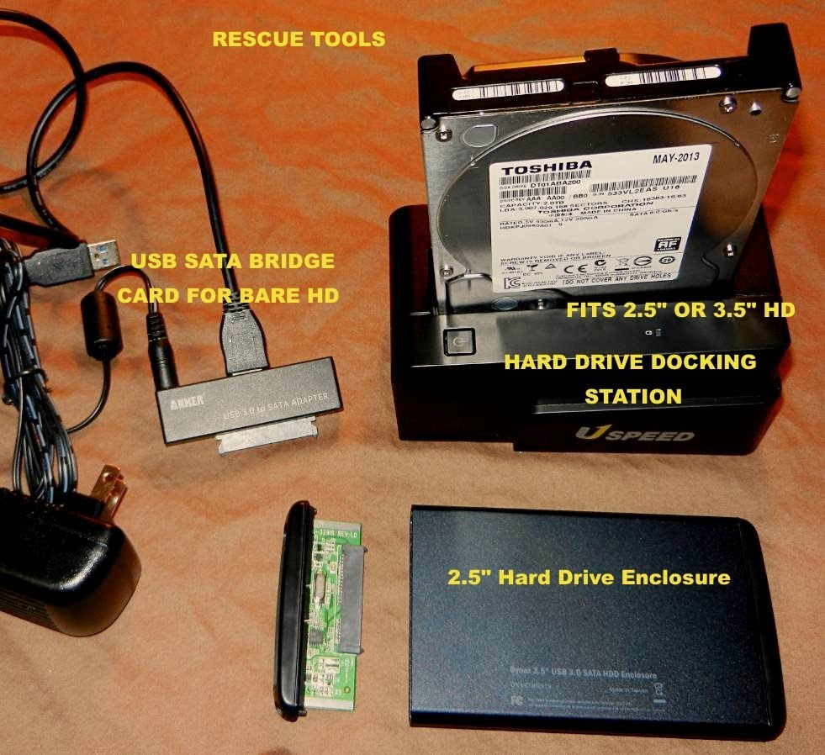

-https://www.youtube.com/watch?v=5cTZBMi-XwQ

Media Drive (Optical Disk Drive In Picture)

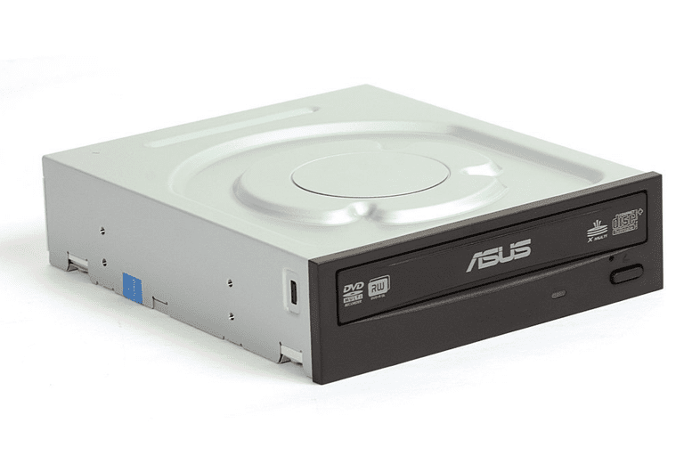

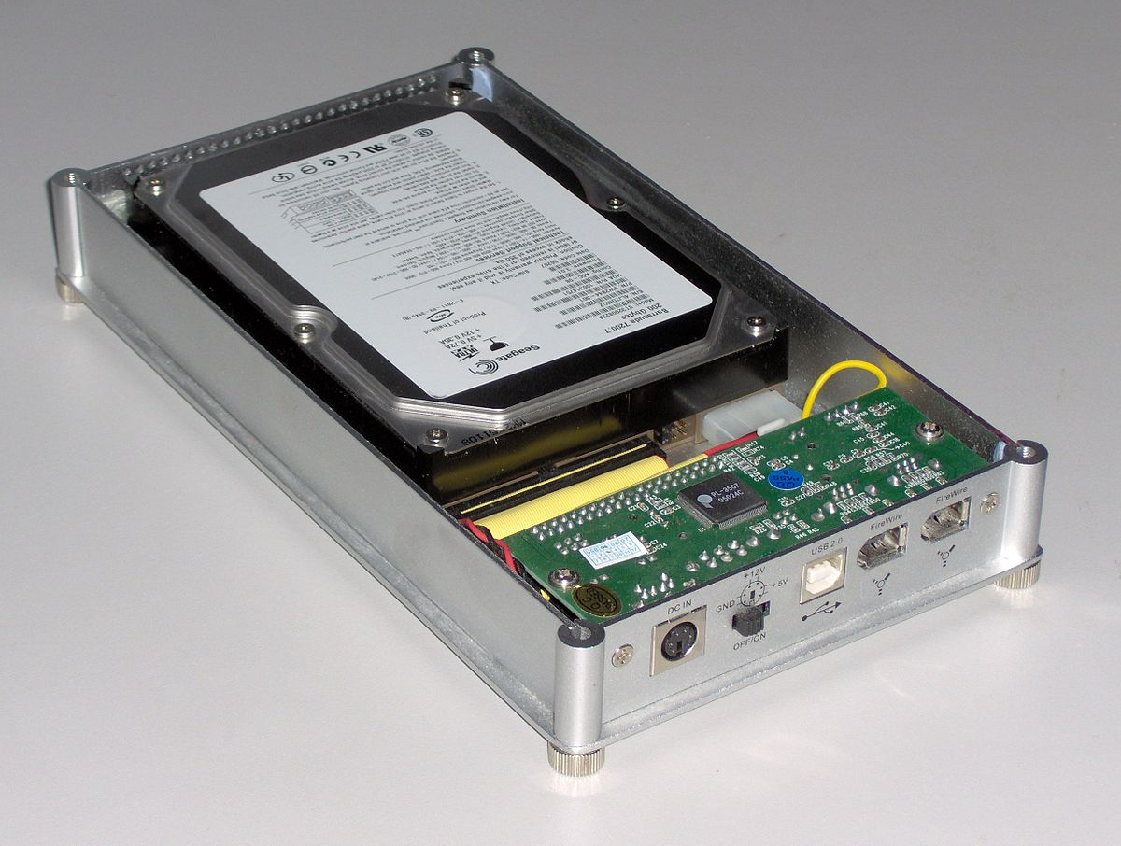

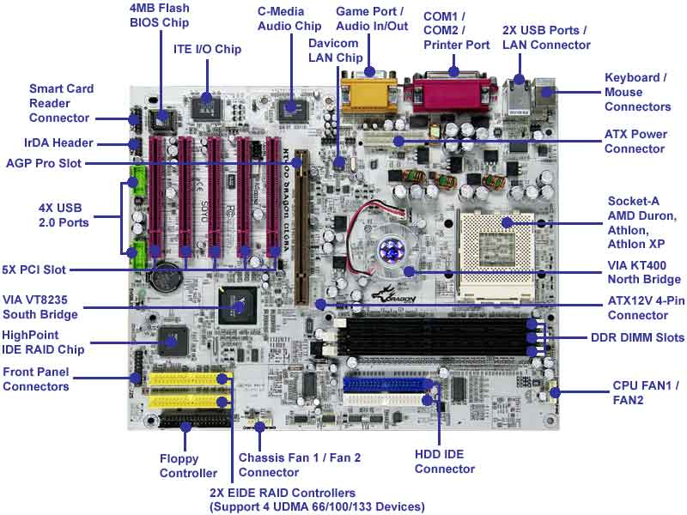

-https://www.anandtech.com/show/1001/2

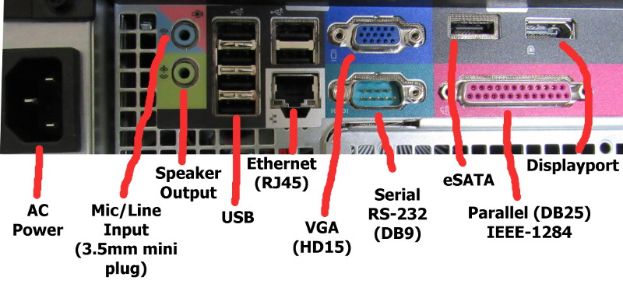

-https://www.ramelectronics.net/connecters.aspx

*Level 1*

1. – First mainframe computer developed by IBM, Automatic Sequence Controlled Calculator (ASCC), solved addition and multiplication in <6 seconds, used thousands of vacuum tubes to operate

-IBM- RAMAC 305 used ascending stack of aluminum discs covered with iron oxide (Data Bank), with this, data was magnetically coded allowing random data to be retrieved from a storage file